Zip Recruiter

Steps:

1. Search anaconda Prompt in Search window of Windows and Click on Run as administrator.

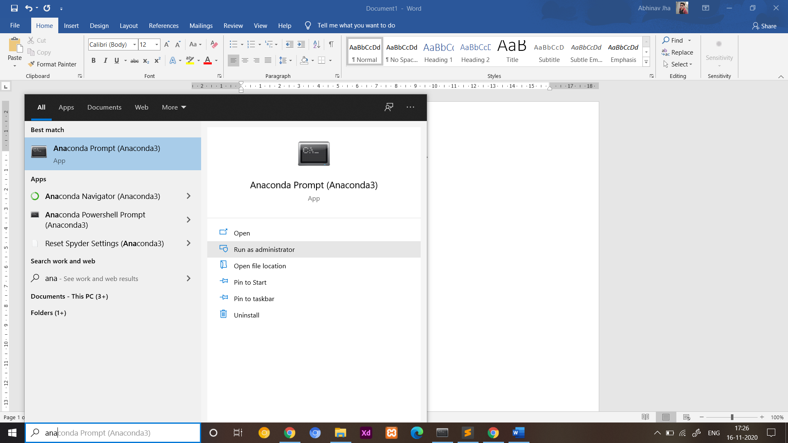

2. Copy the path where you downloaded the project.

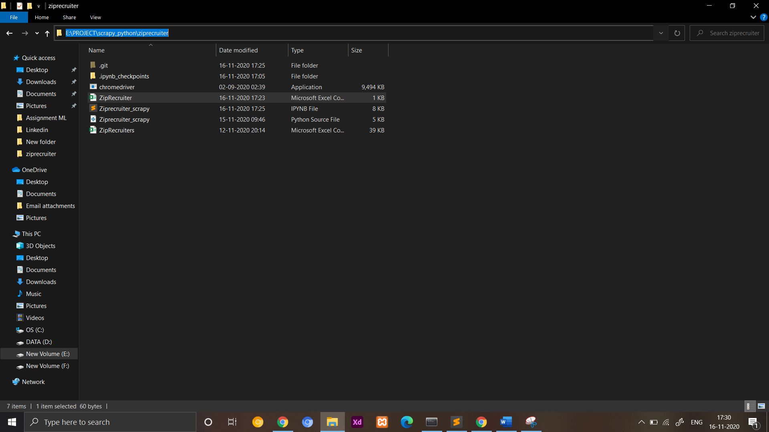

3. Paste this path and press enter in anaconda prompt

Eg: cd E:\PROJECT\scrapy_python\ziprecruiter

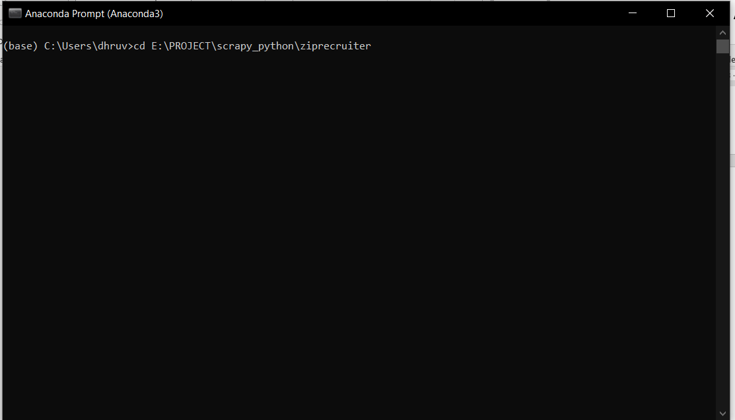

4. Enter the command to open the code and press Enter:

jupyter notebook

It will open a page in browser

Open Ziprecruiter_scrapy

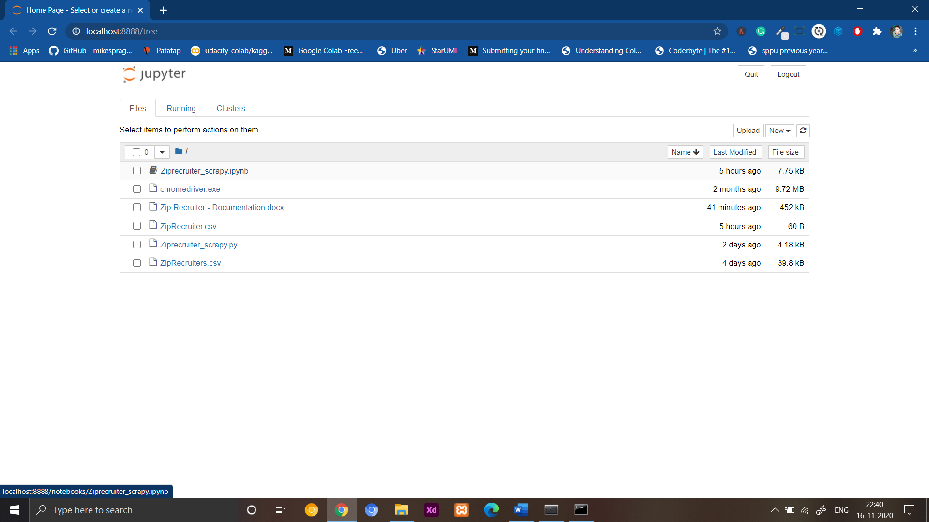

5. Change the link which you want to scrape

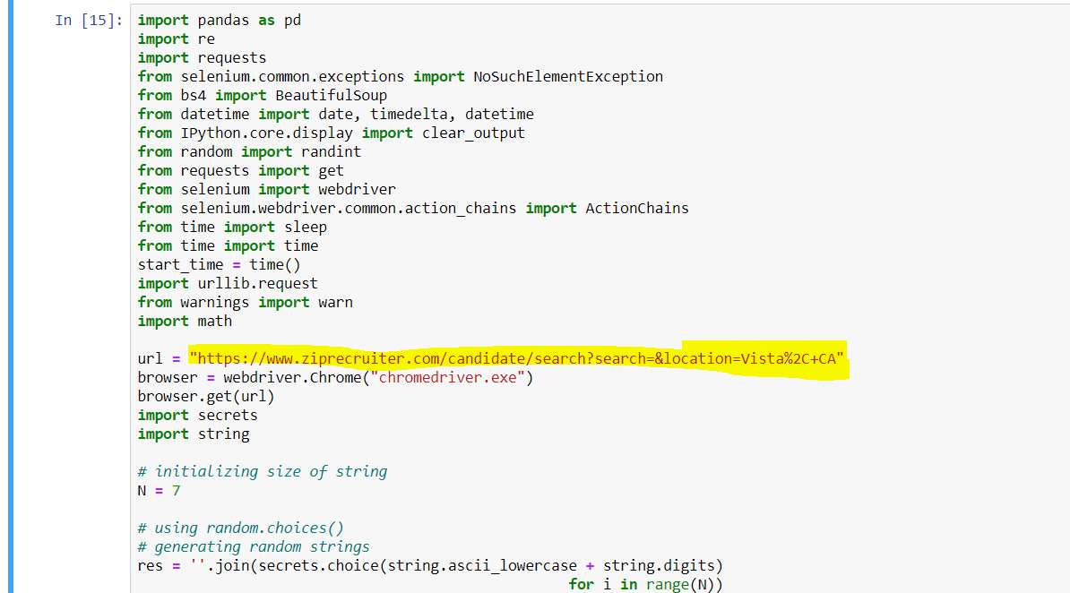

6. To run the command you need to press shift + Enter

It will open the chrome

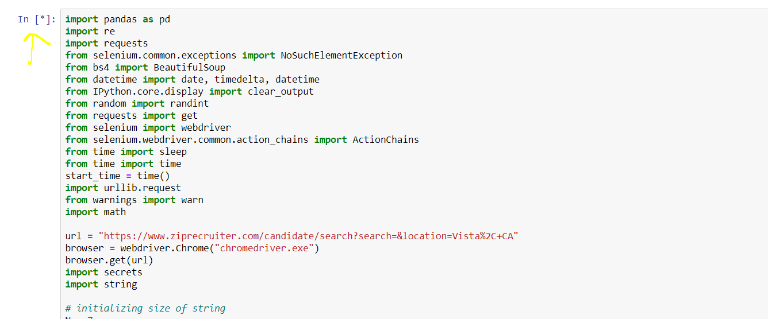

7. After a span of 5 min run the second code using shift+ Enter

8. After the span of 5 min run the third code and wait for 20 min to 25 min.

9.If you want to change the name of file you can edit the last cell.

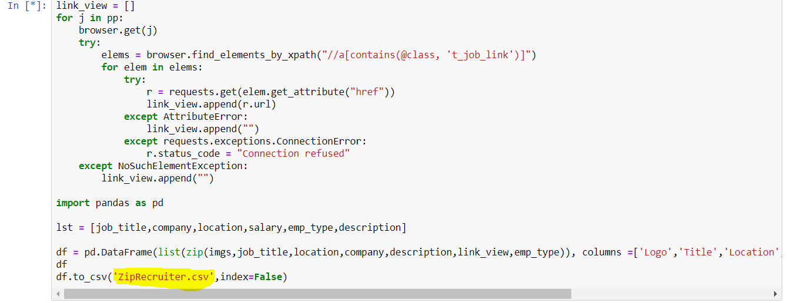

10.If you want to scrape multiple cities then just copy the Ziprecruiter_scrapy file and change the name and follow the steps from step 4 to step 9.

